|  |  |
| --- | --- |
| WEST LONDON WASTE AUTHORITY |  |
| Report of the Managing Director | 23 June 2023 |
| **WLWA 2023-24 Business Plan** | |
| SUMMARY This report provides details of the strategic priorities that will form the basis for the Authority’s Business Plan for 2022/23. The key points are:   * The 2022-23 Business Plan was very ambitious, challenging and has improved how we work. * The joint work with Boroughs to create a Joint Plan for 2030, Infrastructure Investment Plan, and Extended Producer Responsibility Strategy have been rolled over into this year due to legislative delays, but delay represents a financial risk to WLWA and Boroughs if we are not ready to meet legislative demands / carbon taxes. * The strategic priorities create more ambition and more challenges for us as we change the waste system and change people’s perception of the value of waste. This is to mitigate cost increases and ongoing damage to our climate. * The strategic priorities create a focus for employees to link their objectives to the strategic objectives of the Authority, are relevant to all employees and drive changes in the business as usual activities. All of the individual objectives and key results will be put into the Lattice HR software to be shared and visible to colleagues. | |
|  | |
| **RECOMMENDATION(S)**  The Authority is asked to:-   1. *Approve the 2023 Strategic Priorities to shape the Business Plan for 2023-24 and for inclusion in the annual report.* | |

1. **Background** – Since 2019, the Joint Municipal Waste Management Plan and consequently the West London Waste Authority business plan has focused on outcomes whilst we wait for clarity on new environmental legislation and regulations. The authority has developed and cemented its values of Leadership, Empowerment, Agility and Partnership to support these outcomes and agreed a framework plan with Boroughs in 2021. We are using Lattice HR software to publish objectives and key results for all employees linked to strategic priorities. The empowered approach led to a very ambitious and challenging Business Plan in 2022-23 which has driven big improvements in how we work.
2. **Roll over from the 2022-23 Business Plan –** The following items have rolled over from the 2022-23 Business Plan: The HR Strategy, Joint Plan for 2030, Infrastructure Investment Plan, and Extended Producer Responsibility Strategy. With the exception of the HR Strategy, these are all joint pieces of work with Boroughs taking a long view of the changes ahead.
3. **2023-24** **Strategic Priorities -** Over the next 12 months, the period of this business plan, using five strategic priorities we will start to invest in and initiate the change of our waste management model. The strategic priorities for the next 12 months is detailed in Appendix 1. Created by the Senior Leadership team and Managers Group it creates clarity and focus for the organisation to ensure all WLWA colleagues are delivering objectives focused on the same five priorities. The next step is for individual objectives to be put into the HR Lattice software which ensures visibility and alignment.
4. **Financial Implications** – £2.8m will be invested in programmes over three years with savings made directly by Boroughs over the same period. The budget for 2023-24, the period of this Business Plan is limited to £1m investment. These savings will be realised directly to the Boroughs through e.g. reduced cost of collections through routing efficiency, operational savings at recycling sites, the materials collections service and reducing the cost of contaminated recycling. The detail of the savings is to be negotiated with the Boroughs and relies on strong collaborative working. Additional benefits not yet modelled are: re-routing ability to gain maximum benefit from the packaging reforms as the amount and composition of waste and recycling changes and the social value of reuse and waste minimisation realised directly by residents and businesses.

This business plan supports our financial principles of reducing costs, providing stability around WLWA levies, effective management of financial risk and creating infrastructure and collaborative projects with Boroughs to do so. The aim is to continue providing long term stability and predictability as per the finance strategy.

1. **Risk Management** – Public and/or Borough resistance to change is the greatest risk because it will slow down the programmes delivery. The strategic priorities are designed to mitigate this risk by: helping us communicate change to citizens who care about the environment but don’t see the link with waste and resources, providing new great services in trade off for the changes needed, providing data on how using waste as a resource can alleviate social pressure by creating opportunities for training, skills and jobs, increasing data driven decision making and data visualisation to explain the changes, increasing access to services and helping people and systems to keep up with the technical changes.

Detailed planning and the lessons learned from the 2022-23 Business Plan has identified weaknesses that should be addressed during the course of this business plan: Some priorities have multiple point accountability at a senior level in the organisation, each should have a single point of accountability where possible; The timing of the strategic priorities was post budget setting, work on the strategic priorities for 2024-25 will start now, inform the budget 2024-25 and will overtake this business plan in its current form; Empowerment has been a big focus of culture change in 2022-23, this should continue to improve focus and clarity.

1. **Legal Implications** – The Regulations to follow the Environment Act 2021 have not yet been published and are crucial to decision making. Statutory, national and London targets have set the scene for the first few years of our joint municipal waste management strategy whilst we wait for the Regulations that follow the Environment Act 2021:

|  |  |  |  |
| --- | --- | --- | --- |
|  | **UK National target** | **London target** | **Borough target** |
| 1 | Call for evidence: Near elimination of biodegradable waste from landfill by 2028 | Zero biodegradable or recyclable waste to landfill by 2026 |  |
| 2 | Net Zero greenhouse gas emissions by 2050 | Net Zero greenhouse gas emissions by 2030 | Carbon neutral by 2030 |
| 3 | 65% recycling by 2035 | 65% recycling by 2030 |  |
| 4 |  | Zero vehicle emissions by 2050 |  |

The Plastics Tax (Treasury), The Environment Act (Defra), The Electricity Generators Levy and Persistent Organic Pollutants (Environment Agency Regulations) are already having an impact on waste flows.

The full range of legislation and regulation expected is significant and has been put into a handy graphic by Suez, the operating sub-contractor on the residual waste services contract. This has been added in to the strategic priorities in Appendix 1.

1. **Impact upon Carbon reduction**

The business plan aims to reduce waste and focuses on the highest carbon materials for projects. Successful food waste projects, the waste reforms especially Extended Producer Responsibility and social value and reuse programme will reduce the carbon impact of consumption emissions and will be compared against the 2022 baseline. In the event of significant population growth a per head analysis can be carried out.

WLWA 2022 Waste Composition Analysis

Tonnes CO2eq

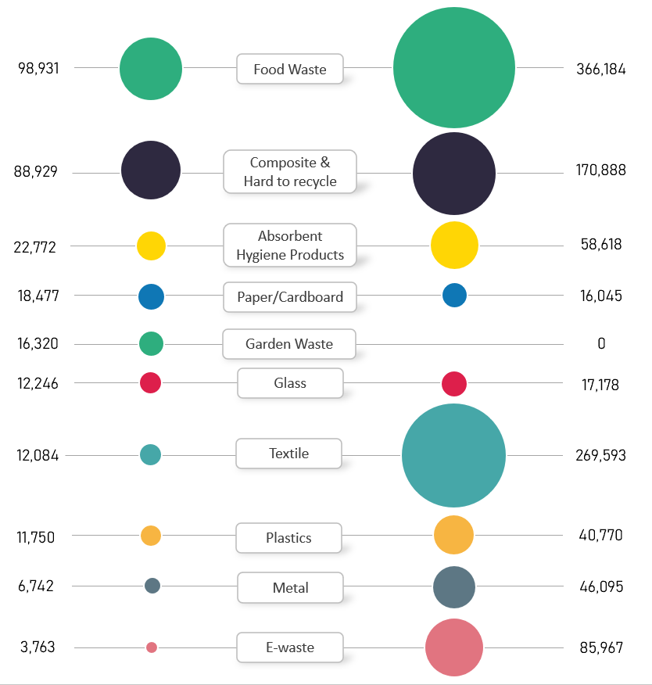

1. **Impact upon the Environment Directors priorities**

The business plan will deliver on the priorities agreed in September 2022.

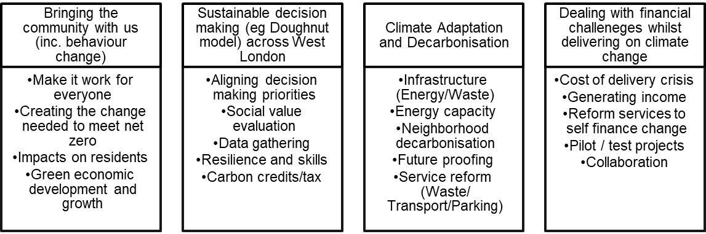

1. **Impact on Joint Municipal Waste Management Strategy**

The business plan will deliver on the framework agreed in March 2022.

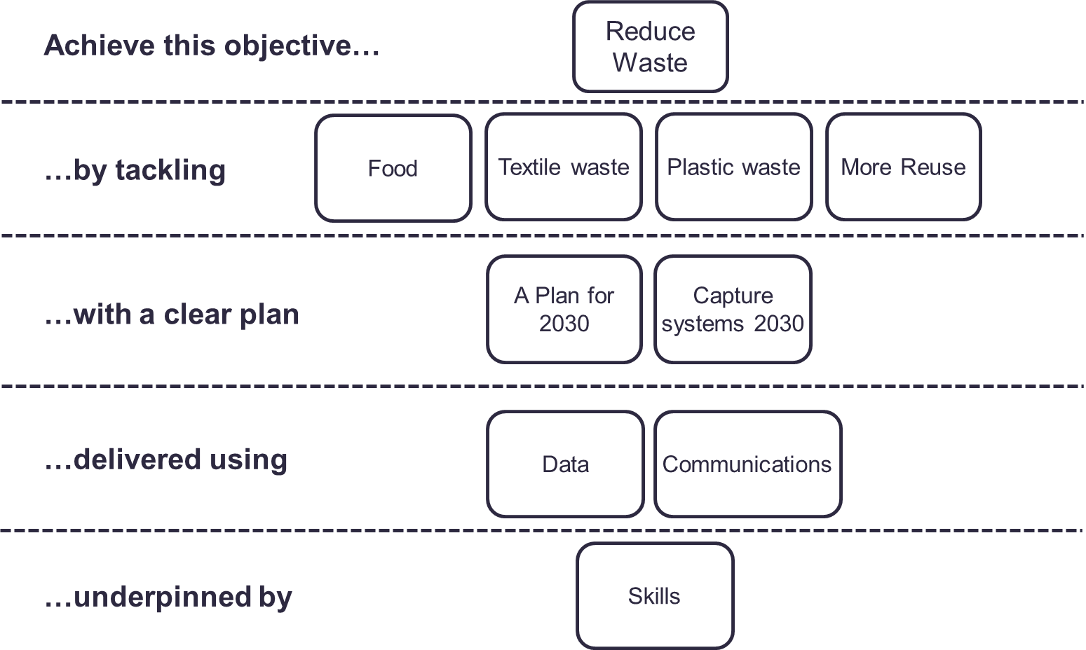

|  |  |  |  |
| --- | --- | --- | --- |
| Background Papers |  | | |
|  | Emma Beal | Managing Director | 07766 147 978 |
|  |  | [emmabeal@westlondonwaste.gov.uk](mailto:emmabeal@westlondonwaste.gov.uk) | |

**Appendix 1**



